Miette Hot Springs Jasper, Alberta November 19, 1950

Dear Family,

As expected, Nick was up today and brought us your letter and the other things which you forwarded. I had been meaning to enquire, but I take it now that our copy of Life's War in Pictures has arrived. Good.

T a1so have the hunting letter so you can disregard paragraph #2 in letter #1.

We have the news of Ruth's latest project. We hope everything turns out alright. We seem to be out of the running At present the box score is:
Ruth: 1 down & 1 to go Helen: 1 down & 1 to go Carol: zero

Enclosed you will find a clipping we found in the Courier. Thought you might be interested if you hadn't seen It already.

Lots of news about Bert, Plattsburg, the dairy farm, Peru, prize cows, selling of cars, beautiful farm house, etc. But no word of the new husband. Whassamatta?
Warm today. Only 2 below.
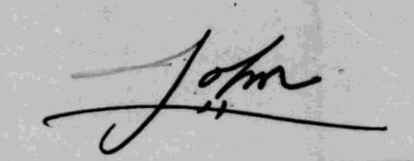

RE: The Leica camera. You should have the money by now. Suggest this be mailed (parcel post, insured) from Fort Erie as there is red tape with regard to cameras. $80 should be enough, but if not get it anyway and I will make up the difference.

